STREET MANAGER OVERVIEW

APRIL 2019

# Contents:

1. Background to Street Manager
2. Ways of working and product delivery
3. Timelines
4. Transition principles and options
5. Technical adoption options: API vs UI
6. Progress so far - Pilot group
7. Business readiness and change
   1. Vision and the change journey
   2. Change principles
   3. Support that will be offered
   4. Business change timelines
   5. Newsletters available
   6. Demo videos of Street Manager
8. Contact

# 

# Introduction to Street Manager

Street Manager is a new digital service that will transform the planning, management and communication of street and road works. It will be for registered users from local highway authorities, utility companies and their contractors.

# 

# Background to Street Manager

The existing system used for managing street and road works was originally developed in the 1990s. Currently each individual local authority, utility company and/or contractor has its own EToN product or software package that is provided by a small number of private sector companies. The technical specification has been updated over the years by the DfT, the last time was in 2013. In early 2017, the DfT began to investigate whether or not the current system was fit for purpose in terms of the technology it uses, the needs of the user community and the rising demand for up to date and accurate data about road works. People were reporting frustrations about:

* the timeliness and accuracy of data
* a lack of visibility of the data across different local authority areas
* high costs
* the need for updates to reflect current needs and
* inconsistent systems and data.

To address the gap, the DfT worked with users from local authorities and utility companies to develop a new digital service - Street Manager - that would enable a single source of accurate, up to date and open data on road and street works with the vision of transforming the planning, management and communication of street and road works to ultimately minimise disruption and improve journeys for the public. The image below shows the benefits of the new system.

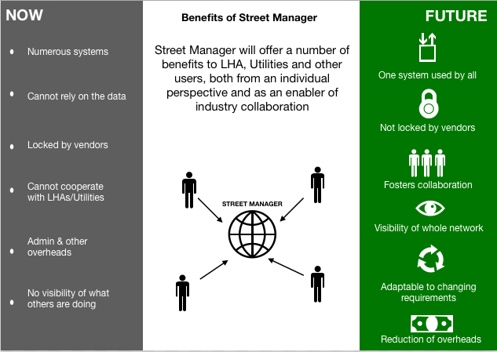

Street Manager provides an opportunity for the industry to develop a service which promotes process optimisation, flexibility, transparency and data accuracy, while enabling collaboration through open data and enhanced functionality.

# Ways of working and product delivery

In line with the Government Digital Service (GDS) guidelines, the Street Manager project is being conducted in an agile way, meaning that we are following an iterative development approach. We build the basics of the product first and then, based on regular user testing feedback, we enhance as we go. It provides the ability to adapt the product to meet changing user needs all the time. This means that you, as users, get to access the new service earlier and also we are able to continuously improve the service.

The analogy we like to use is of building a house - you build the basic walls and roof first so that you can move in straight away but then you can choose what curtains or kitchen tiles you want when you’ve moved in.

Our principles:

**Focus on user needs**

The design and development is user-centric to address currently unmet user needs

**Keep improving the service**

MVP (minimum viable product) provides initial functionality, which is constantly being enhanced in line with user requirements

**Keep improving the way the team works**

Whilst developing the product, the project is also improving the way it is organised and the way it engages with key stakeholders

**Fail fast, learn quickly**

Success is the ultimate goal, however the project ensures learning from mistakes

**Keep planning**

Constant review of scope and priorities to ensure they are still relevant

# 

# Timelines

Street Manager is now in the beta development phase. This is when we build, test and roll out the service. The beta development phase is split into private beta, where we work with a closed group of users, and then public beta which is when other users can start using the service.

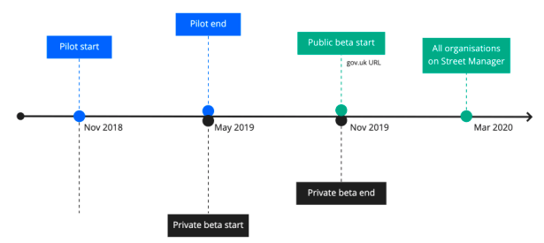

In line with feedback from users, we have reduced the length of the public beta period to five months to minimise some of the transition issues such as dual running. It will now be between November and March 2020, when legislation will be changed to make Street Manager the sole service that should be used. The DfT hopes to publish a consultation shortly that will provide more information on the legislative changes.

# Transition principles and options

Each organisation is free to decide when (between now and March 2020) and how to transition to Street Manager and is responsible for the design and execution of its own change plan to ensure that it suits its individual needs. However, due to the intricate link between organisations in regions, it is recommended that a regional approach to transition is considered as this might be the smoothest, least complicated and timely way to go through the change.

So far, a selection of large regional and national organisations have taken part in the pilot phase to test the service. However, as we go into the private beta phase, we have started to see regional clusters of organisations from the same areas moving together to the new ways of working.

When it comes to moving to Street Manager, it is also important to consider different alternatives for system usage - e.g. overnight switch of all works compared to a phased approach where types of work are moved to the system gradually. Both approaches have certain benefits and disadvantages, which you and your organisation will have to consider and there is no one-size-fit-all solution.

**1) OVERNIGHT SWITCH**

E.g. organisation uses EToN one day and Street Manager the next. Moves all works at the same time across all areas

**Benefits:**

* Shorter transition window
* Single system/source of truth
* Standardised ways of working
* All teams moving together at the same time

**To Consider:**

1. Potential disruptions to business as usual (BAU) work
2. A larger change to manage
3. Risks?

**2) PHASED APPROACH**

E.g. organisation starts using Street Manager for one type of work or one area or with one team

**Benefits:**

* Gradual introduction of change
* Feedback ideas for improvement
* Support change management
* Opportunity to test in smaller area

**To Consider:**

1. Longer transition period
2. Potential for silos developing
3. Risks?

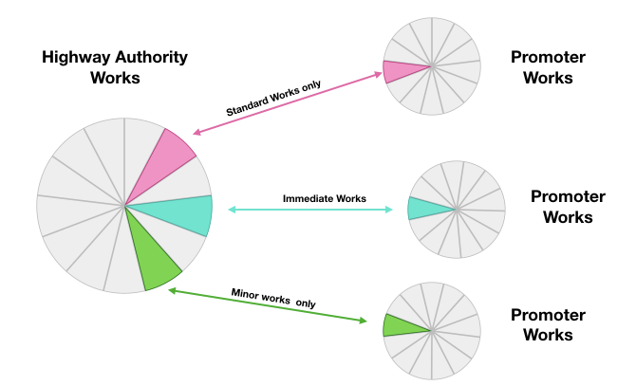

# Technical adoption options: API vs UI

Similarly, each organisation can decide on the most suitable adoption approach for using Street Manager: whether to use the web app user interface (UI), to continue using current systems and link the data to Street Manager via application programming interface (API), or a combination of both. The factors around which of the three options to choose will be dependent on needs unique to each organisation. The below visuals outline some of the key considerations that need to be taken into account when comparing UI and API.

It is of course also possible to operate across both the API and UI (for example using API for works where a link to asset management system is needed, and UI for the rest), thus combining some of the benefits of both options.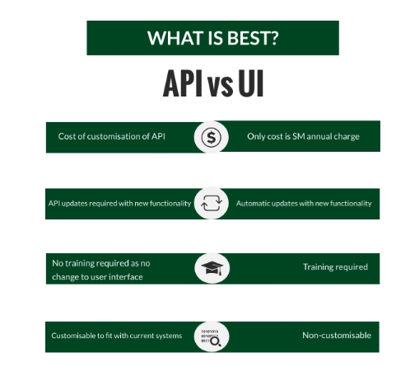

The following pages provide an outline of the key steps that need to be undertaken for adoption via UI and via API. However, how exactly these steps are delivered will vary to a certain extent for each organisation.

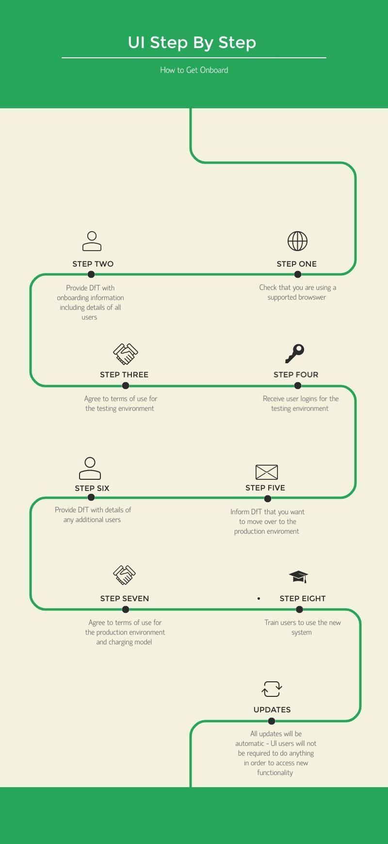

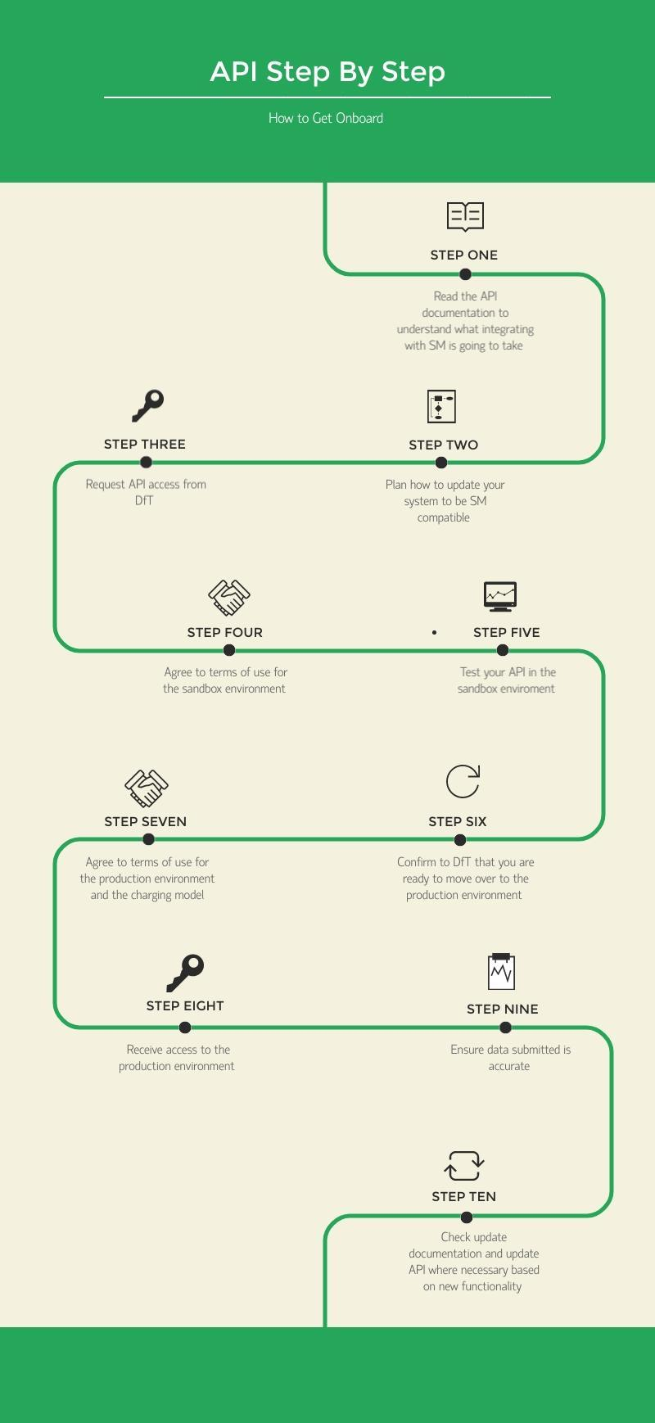

The API timelines differ from those of the project, giving a chance to organisations to start early API testing and development. The API timelines can be seen in the below image:

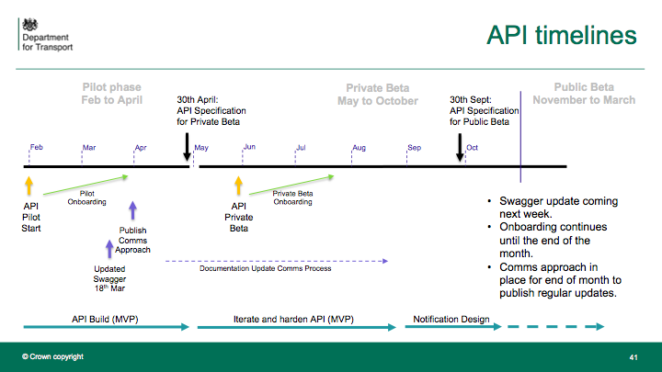

# Progress so far - Pilot group

We have had 15 users from 5 organisations involved in the pilot group with 14 onsite visits having taken place to observe pilot users. Since the start of the pilot in November, over 380 slack messages have been exchanged. Our pilot users have:

* Created 720 work permits
* Raised 750 permit applications
* Granted 405 permits and refused 73 applications
* Commented on 79 permits

We are very grateful to Thames Water, Cadent, Transport for London, Hertfordshire and UK Power Networks for their contribution so far.

# Business readiness and change

## Vision and the change journey

Our aim is to help **engage all stakeholders**, **build awareness**, and **support the adoption** of the new Street Manager system so that all users get its **maximum benefits** and **transition happens in the smoothest** possible way for all organisations

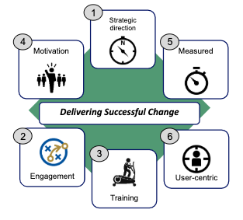

To be effective, a change programme should:

1. Provide clarity and strategic direction so that everyone understands the direction of travel
2. Engage stakeholders at all levels with ongoing open communication
3. And training support
4. So that they feel motivated, empowered and confident they will fit into the new ways of working
5. Have outcomes that can be measured and adjusted if required, and
6. Most importantly, recognising that each organisation, team or individual will have unique challenges and needs, it should have a user-centric approach

We understand that change comes with uncertainty and nervousness about what the future holds and how to get there.

We believe that the key components of any change journey are

**1. INVOLVEMENT** (*so that everyone is able to shape their own journey)*,

**2. ENGAGEMENT** *(so that everyone is kept informed and listened to)* and

**3. EDUCATION** *(so that everyone is comfortable with the new systems, processes and ways of working)*,

and only by completing all three of them can you successfully complete the journey.

Every organisation will decide how to shape and go through that journey and the DfT Business change team will be there to provide support at every step of the way.

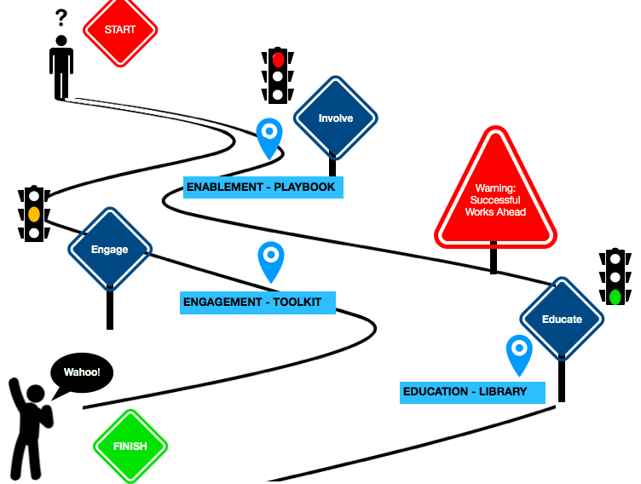

## Change principles

The way that the Business change will structure the offered support will be aligned to the three elements of your change journey:

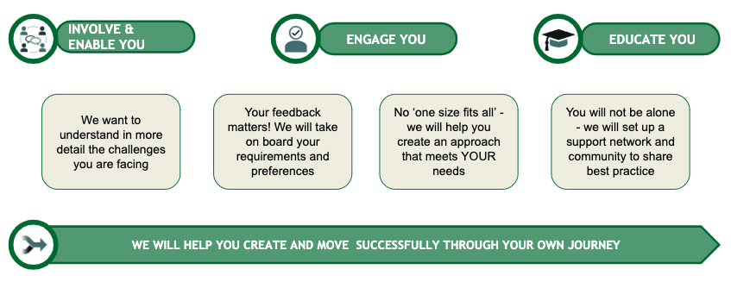

We know that managing change can be a challenging task, regardless of whether your organisation is big or small.

To help you transition as easily as possible, we will equip you with a library of business change materials, templates and tools, and support you with the capabilities you need to understand, drive and deliver transition successfully.

## Support that will be offered

**1) Enablement Playbook and Support Network**

We will provide materials and guidance to help you deliver effectively and smoothly change in your organisation.

Examples of how we could help you:

**Tools to help you understand the impact and how ready you are to embark on the change journey, e.g.:**

* + Impact assessment tool
  + Change readiness tool
  + Stakeholder analysis
  + Business case
  + Benefits definition approach
  + Data protection impact assessment
  + Commercial information
  + FAQ

**Change approach to help you address the needs identified from your impact assessment, e.g.:**

* + Personas / user profiles
  + Change management strategy
  + Communications approach
  + Training approach
  + Roadmap
  + A RACI framework to assign level of responsibility and authority to show who is Responsible, Accountable, Consulted, and Informed in relation to different activities

**Tools to monitor your progress and success of interventions**

* + Risks, actions and issues (RAID) log
  + Roll-out plan
  + Status report
  + Benefits tracker
  + Feedback tool



**Support network setup and local, regional and national communities of practice to share best practice**

**2) Engagement toolkit and communications**

We will ensure you are engaged throughout the transition period through regular communications.

Examples of how we could help you:

**Communication strategy to help you deliver business change in your organisation**

* + Key messages
  + Key desired outcomes from engagement
  + Tools to measure effectiveness
  + Channels analysis

**Engagement plan: schedule, curriculum, delivery methods**

* + Engagement activities
  + Target delivery dates aligning to project timescales
  + Checkpoints

**Communications techniques and delivery method options to support your organisation**

* + Presentations
  + Web conferences
  + Pull-up posters
  + Printed material
  + Videos
  + Slack
  + Email
  + Newsletters

**3) Education library and training support**

We will provide training material related to the deployment of the new process and technology.

Examples of how we could help you:

**Tool to identify what training you will need**

* + Questionnaire and analytical tool to assess the training needs of different stakeholders:
  + System training
  + Training in new processes
  + Level of detail required
  + Tools to assess the effectiveness of training intervention

**Training plan: schedule, curriculum, delivery methods**

* + Training activities
  + Target delivery dates aligning to project timescales
  + Checkpoints

**Training techniques and delivery method options**

* + Reference material
  + Videos / online demos
  + FAQ / Q&A
  + Drop-ins
  + F2F instructor-led

## Business change timelines

**DfT Business Change team will support you by:**

1. Providing Enablement playbook, Engagement and Education toolkits that you can tailor to your needs and use to manage the change in your organisation - these will be provided well in advance of transition
2. Delivering programme-wide and focused communication to all impacted stakeholders
3. Supporting the delivery of innovative ways of training and education

Below is an indicative timeline of the engagement and support that will be offered.

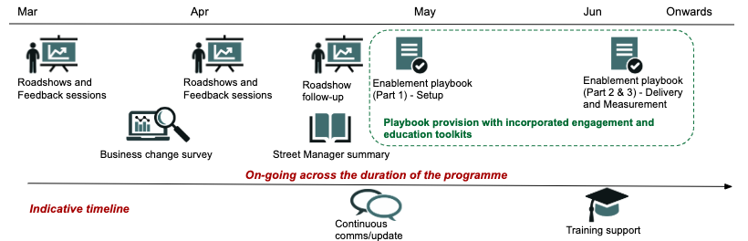

## **Publicly available Street Manager documentation:**

## [Link to repository](https://departmentfortransport.github.io/street-manager-docs/)

## Newsletters available:

[Newsletter 9 - February 2019](https://dftstreetmanager.slack.com/files/UBXK16KGV/FHDKF5TE2/190319_street_manager_newsletter_9.pdf)

[Newsletter 8 - 17 January 2019](http://hauc-uk.org.uk/uploads/190117_Street%20Manager%20Newsletter%208.pdf)

[Newsletter 7 - 7 December 2018](http://hauc-uk.org.uk/uploads/181207_Street%20Manager%20Newsletter%207.pdf)

[Newsletter 6 - 18 October 2018](http://hauc-uk.org.uk/uploads/181018_Street%20Manager%20Newsletter%206.pdf)

[Newsletter 5 - 27 September 2018](http://hauc-uk.org.uk/uploads/180927_Street%20Manager%20Newsletter%205.pdf)

[Newsletter 4 - 11 September 2018](http://hauc-uk.org.uk/uploads/180911_Street%20Manager%20Newsletter%204.pdf)

[Newsletter 3 - 23 August 2018](http://hauc-uk.org.uk/uploads/180823_Street%20Manager%20Newsletter%203.pdf)

[Newsletter 2 - 24 July 2018](http://hauc-uk.org.uk/uploads/180724_Street%20Manager%20Newsletter%202.pdf)

[Newsletter 1 - 2 July 2018](http://hauc-uk.org.uk/uploads/180702_Street%20Manager%20Newsletter%201.pdf)

## Demo videos of Street Manager:

[*Street Manager Hole Stories - YouTube channel*](https://www.youtube.com/channel/UC2U1cjhn4KGPDCwzqc-tvbg/)

## Other news and updates:

[Slack channel: #newsandslides](https://dftstreetmanager.slack.com/messages/CD2EXEXEC/team/)

[Slack channel: #general](https://dftstreetmanager.slack.com/messages/CBEDGK4NR/team/)

# Contact

If you have any questions, do not hesitate to get in touch via

* [streetmanager@dft.gov.uk](mailto:streetmanager@dft.gov.uk)
* Slack: [#askdft](https://dftstreetmanager.slack.com/messages/CC7TUCMEY/team/)